**The E-Learning Platform**

# Purpose of the document

The purpose of this document is to explain the proper working of the system. It can help externals and users to know the functions of the system. Moreover, this documentation will help the developers to keep in mind what they already have done and how this project can help them in doing some other projects, and hence new ideas can be generated through this documentation.

# Proposed Architecture

The proposed architecture is based on a popular three-tier architecture. At the very bottom layer, the data-related services will be hosted. It tells how Data Layers help and works ; LMS can be made better; and hence a complete E-Portfolio would be accomplished for all the students. The second layer is the business logic layer where all the control will be done on the data using a programming language. It could be seen that all the working of the projects has been explained in the details. The very top layer is the presentation layer. On this layer, the presentation takes place where the interface of the learning process, pedagogy process institutional process, and technical measure take place.

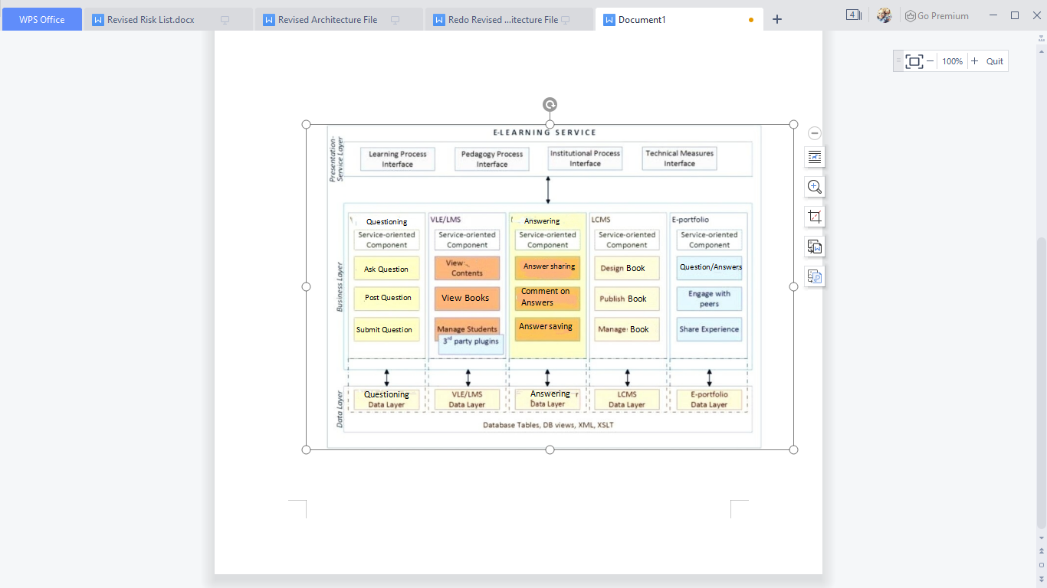

Figure 1 Proposed Architectural Design of E-Learning Platform

## Data Layer

At the very bottom of the architecture, there is a data layer. Any e-learning system. It can be said that any dynamic system is incomplete without data. If data will not be given, the system will not work properly, authentically and associated with the corresponding data according to the requirements. The data, therefore, needs to be meticulously stored as well. So that all the details, output and results can be according to the corresponding data. Eventually, some of the technologies shall be leveraged to work properly and accordingly. The very technology that will be used is a database engine. Moreover, for clarity, different modules have been made of the data layers for the different modules of the business layer. These modules explain all the strategies that were observed and would be utilized for the proper functioning of the system.

### Database engine

The DBMS system helps in CRUD that is creating, reading, updating, and deleting. The database engine shall be the primary technology where most of the data will be stored. However, the choice of database is important and will be decided later after considering the details and conducting a feasibility study of different available choices. However, to give an idea, if the project stakeholder decides to go with a no-SQL database, then MongoDB shall be at the top of the priority list. If it is decided that a relational database engine is to be used, then MySQL plays the best role in completing the system requirements thoroughly.

### XML

The uses of Extensible Markup Language (XML) are many. It tells how the users will see the system and the appearance of the system in front of all the students or users. However, for the purpose of this project, the primary usage will be storing the configurations, both the user’s entered and system-related. XML always works in properly designing GUI and it is always better to provide the system with eye-catchy layouts which are easy to use and interact with.

## Business Layer

The business layer works as the back-end and controls all the functions of the system. The business layer is divided into different sections based upon the functionalities it offers. For instance, a forum to ask questions by the users and provide it to the ones who answer.

## Presentation Layer

There shall be following interfaces. All these interfaces shall be accessible on the basis of the rights of the user.

1. **Learning Process Interface**

Learning Process Interface plays the role of bringing the information in front of the users to learn from the system. Shall be used by both the students and staff (including faculty members). The students can manage their courses, ask questions, solve their problems, as well as all the students can locate the learning resources, etc.

1. **Pedagogy Process Interface**

As the system is basically a platform of teaching, pedagogy plays its role. This interface is mainly based on interaction with Learning Content Management System (LCMS).

1. **Technical Measures Interface**

All the technical measures, such as ensuring security, can be done using this interface. The technical measure interface also includes tasks such as assigning roles to users, revoking rights, etc.

# Constraints

1. To build a General Data Protection Regulation (GDPR) compliant system.

2. The system shall be reliable and should be available at all times.

3. The performance of the system should be very high.

4. The system should be easy and eye-catchy to use.

5. Students’ data should be stored side by side.

6. The questions asked by the students should be reached to teachers.

7. The data stored in the system shall be encrypted.

8. The integrity of the data shall be protected and should be reached by different students to eradicate their confusion in advance.

9. Unauthorized accesses shall be prevented at all levels, and if breached a log must be maintained thereafter.

10. It should not be for a limited number of students.

# Architecture Criteria

LCAM is seen as the second major and important project milestone. While working on software, following points were kept in mind:

1. The visions were kept stable; all the requirements were considered and a complete architecture was given priority.

2. Major risks were eliminated side by side and were revolved by a complete process of testing.

3. All the executable prototypes were evaluated first.

4. Iteration plans were given priority and were constructed with incomplete details.

5. Credentials were estimated and generated to allow users to assess the details and hence work to proceed.

6. Agreement of stakeholders was given special importance so that the project was executed to reach the top of the current architecture.

# Use Cases

Following are some of the use cases of the system.

## 

Figure 2 System Use Case

Login/out

This feature allows the system to interact with the system through a proper channel. It allows only students to log in to the system when needed. In this way, the system stays protected from unknown people who may spoil the proper arrangement and features of the system.

Register with System

As discussed earlier, only registered students will be able to ask questions, and hence teachers will be able to answer students according to students’ age level.

# System Qualities

The architecture, as well as the CCRD use case, explain in detail that all the functions were implemented to improve the qualities of the system. The architecture throws light on the details of the proper functioning of the system. It tells how students will interact with the teachers through this platform. It is important for students and teachers to stay in touch for the proper functioning of the system. Therefore, the system was also given the option of credentials that allow users to approach and use the system.

# Elaboration Phase

Different lessons were learned during the elaboration phase. During the elaboration phase, it was given importance to mitigate technical as well as non-technical problems and risks. Moreover, functional and non-functional concerns were considered and were mitigated. The elaboration phase helped to get a complete and more detailed understanding of the requirements and features of the system. It helped to address architecture, schedule, requirements, and costs among many others. The elaboration phase helped in proper designing, validation, implementation, and hence the establishment of the final architecture. All the details were kept saved in the form of a change log that would be helping in upcoming projects.